Long Division of Polynomials  Quiz-Answers | Name:  Date:

- 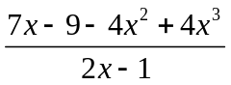 Answer: 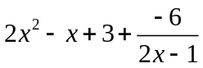

- 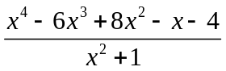 Answer: 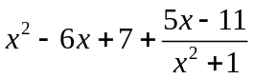

- 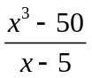 Answer: 